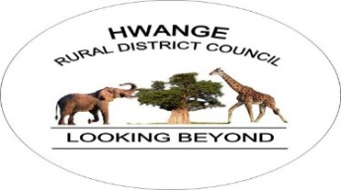

HWANGE RURAL DISTRICT COUNCIL
DEPARTMENT OF NATURAL RESOURCES & MATERIALS SERVICES
SAND AND AGGREGATE PRODUCTS PRICE GUIDE
Hwange Rural District Council wishes to inform all valued clients, contractors, developers, and stakeholders of the available sand abstraction services and construction material products offered by the department.
The following rates are currently applicable:

1. MATERIALS COLLECTED DIRECTLY FROM THE RIVER
Product | Price
River Sand | USD 11 per cubic metre
Pit Sand | USD 11 per cubic metre

2. MATERIALS COLLECTED FROM COUNCIL STOCKPILE
Product | Price
River Sand | USD 17 per cubic metre
Pit Sand | USD 17 per cubic metre

3. SAND ABSTRACTION SERVICES
Service | Price
Sand Abstraction Contract Site Levy | USD 1,000

4. OTHER MATERIALS AVAILABLE
Material | Price
Dirty Gravel | USD 2.50 per cubic metre
Various Stones | USD 5.00 per cubic metre
Organic Matter / Clay | USD 10.00 per cubic metre

IMPORTANT NOTICE
- All payments must be made through official Hwange Rural District Council payment channels.
- Prices are subject to review without prior notice.
- Transportation arrangements are the responsibility of the client unless otherwise agreed.
- Clients are encouraged to contact Council offices for further clarification and site allocation procedures.
For more information, please contact:
Hwange Rural District Council

